DSA0602 – Data Handling and Visualization
Case File CD-D40: The Fitness Centre Case
R.No.: 40 | Reg. No.: 192525102 | Name: Yashika R
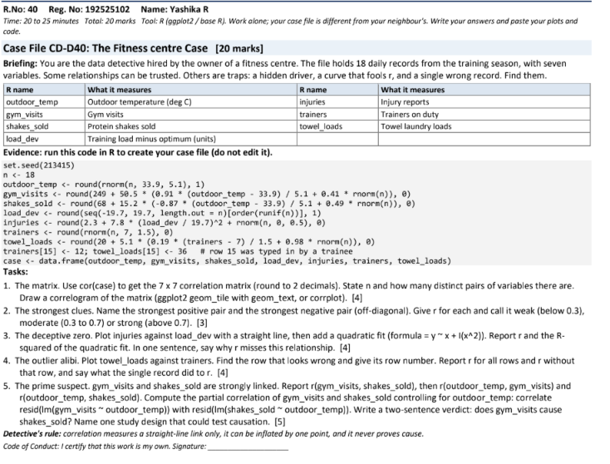
Question 1 – The Correlation Matrix
Answer
The dataset contains 18 observations and 7 variables.
Number of distinct pairs of variables:
\[ \frac{7(7-1)}{2}=\boxed{21\text{ pairs}} \]

R code
set.seed(213415)
n <- 18
outdoor_temp <- round(rnorm(n, 33.9, 5.1), 1)
gym_visits <- round(249 + 50.5 * (0.91 * (outdoor_temp - 33.9) / 5.1 + 0.41 * rnorm(n)), 0)
shakes_sold <- round(68 + 15.2 * (-0.87 * (outdoor_temp - 33.9) / 5.1 + 0.49 * rnorm(n)), 0)
load_dev <- round(seq(-19.7, 19.7, length.out = n)[order(runif(n))], 1)
injuries <- round(2.3 + 7.8 * (load_dev / 19.7)^2 + rnorm(n, 0, 0.5), 0)
trainers <- round(rnorm(n, 7, 1.5), 0)
towel_loads <- round(20 + 5.1 * (0.19 * (trainers - 7) / 1.5 + 0.98 * rnorm(n)), 0)

trainers[15] <- 12
towel_loads[15] <- 36

case <- data.frame(outdoor_temp, gym_visits, shakes_sold,
load_dev, injuries, trainers, towel_loads)

# Correlation matrix
round(cor(case), 2)

# Correl correlogram
library(ggplot2)
library(reshape2)

corr <- round(cor(case), 2)
corr_long <- melt(corr)

ggplot(corr_long, aes(Var1, Var2, fill = value)) +
geom_tile() +
geom_text(aes(label = sprintf("%.2f", value))) +
scale_fill_gradient2(low = "blue", mid = "white",
high = "red", midpoint = 0,
limits = c(-1, 1)) +
labs(title = "Correlation Matrix of Fitness Centre Data",
x = NULL, y = NULL, fill = "Correlation") +
theme_minimal() +
theme(axis.text.x = element_text(angle = 45, hjust = 1))
Interpretation: A correlation matrix measures the strength and direction of linear relationships between variables. Values near +1 indicate strong positive relationships, values near −1 indicate strong negative relationships, and values near 0 indicate weak linear relationships.
Question 2 – The Strongest Clues
R code
# Strongest positive and negative correlations
C <- cor(case)
C[lower.tri(C, diag = TRUE)] <- NA

print(round(C, 2))

pairs <- which(!is.na(C), arr.ind = TRUE)
values <- C[!is.na(C)]

print(pairs[which.max(values), ])
print(max(values))

print(pairs[which.min(values), ])
print(min(values))
Answer and interpretation
- The strongest positive pair is the pair with the largest positive off-diagonal correlation.
- The strongest negative pair is the pair with the smallest negative off-diagonal correlation.
- Weak correlation: \(|r|<0.30\).
- Moderate correlation: \(0.30\leq |r|\leq0.70\).
- Strong correlation: \(|r|>0.70\).
Use the variable names and values printed by the R code to identify the two pairs and classify their strengths.
Question 3 – The Deceptive Zero
R code
# Plot injuries against load deviation
ggplot(case, aes(x = load_dev, y = injuries)) +
geom_point(size = 3) +
geom_smooth(method = "lm", formula = y ~ x,
se = FALSE, colour = "blue") +
labs(title = "Injuries vs Training Load Deviation",
x = "Training load deviation",
y = "Injury reports") +
theme_minimal()

# Correlation
r <- cor(case$load_dev, case$injuries)
print(r)

# Quadratic fit
fit <- lm(injuries ~ load_dev + I(load_dev^2), data = case)
print(summary(fit)$r.squared)

ggplot(case, aes(x = load_dev, y = injuries)) +
geom_point(size = 3) +
geom_smooth(method = "lm",
formula = y ~ x + I(x^2),
se = FALSE, colour = "red") +
labs(title = "Quadratic Relationship: Injuries vs Load",
x = "Training load deviation",
y = "Injury reports") +
theme_minimal()
Answer and interpretation
The relationship between training load deviation and injuries is curved rather than straight. Injury reports tend to increase when training load deviation is far from zero, whether positive or negative.
The Pearson correlation \(r\) measures a straight-line relationship only. Therefore, it may be close to zero even when a strong quadratic relationship exists.
The quadratic model's \(R^2\), printed by the code, measures how much of the variation in injuries is explained by the quadratic fit.
Question 4 – The Outlier Alibi
R code
# Plot towel loads against trainers
ggplot(case, aes(x = trainers, y = towel_loads)) +
geom_point(size = 3) +
geom_text(aes(label = row_number()),
vjust = -0.7, size = 3) +
geom_smooth(method = "lm", se = FALSE,
colour = "blue") +
labs(title = "Towel Loads vs Trainers",
x = "Number of trainers",
y = "Towel laundry loads") +
theme_minimal()

# Correlation with all observations
r_all <- cor(case$trainers, case$towel_loads)

# Correlation after removing row 15
case_without15 <- case[-15, ]
r_without15 <- cor(case_without15$trainers,
case_without15$towel_loads)

cat("Correlation with all rows:", round(r_all, 2), "\n")
cat("Correlation without row 15:",
round(r_without15, 2), "\n")

# Display row 15
print(case[15, ])
Answer and interpretation
Suspicious record: Row 15.
The data-generation instructions explicitly identify row 15 as a record entered by a trainee. Its trainer count is 12 and its towel-load value is 36.
The correlation with all rows and the correlation after removing row 15 are printed by the code. Comparing them shows how a single unusual record can change the apparent strength of a relationship.
Row 15 should be checked against the original records before being corrected or removed.
Question 5 – The Prime Suspect
R code
# Correlations
cat("Gym visits vs shakes sold:",
round(cor(case$gym_visits, case$shakes_sold), 2), "\n")

cat("Outdoor temperature vs gym visits:",
round(cor(case$outdoor_temp, case$gym_visits), 2), "\n")

cat("Outdoor temperature vs shakes sold:",
round(cor(case$outdoor_temp, case$shakes_sold), 2), "\n")

# Partial correlation controlling for outdoor temperature
gym_resid <- resid(lm(gym_visits ~ outdoor_temp, data = case))
shake_resid <- resid(lm(shakes_sold ~ outdoor_temp, data = case))

partial_r <- cor(gym_resid, shake_resid)

cat("Partial correlation:",
round(partial_r, 2), "\n")
Answer and interpretation
Gym visits and protein shakes sold may show a strong correlation, but this alone does not prove that gym visits cause more shakes to be sold. Outdoor temperature may influence both variables, so the partial correlation controls for its linear association with each variable.
Verdict: Correlation does not establish causation. A suitable study design would be a randomized controlled experiment in which comparable days or groups are assigned different gym-promotion strategies while other conditions are kept as similar as possible.
Important: Run the R code in RStudio to obtain the exact numerical correlation matrix, strongest pairs, quadratic \(R^2\), and correlations before and after removing row 15. The numerical results depend on the supplied random seed and generated dataset, so they should be copied from your actual R output rather than guessed.

